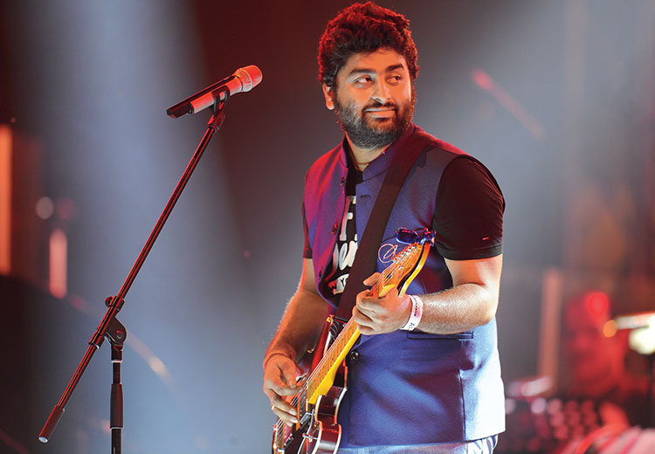Arif Singh

Full Name:

 Arijit Singh

Date of Birth:

25th April 1987

Place of Birth:

  Jiaganj, Murshidabad, West Bengal, India.

Occupation:

  Singer, Actor, Songwrite

Personal Life:

Arijit Singh is known to be a private individual when it comes to his personal life. He is married to Sara Bharwana, and the couple has children. Arijit Singh contribution to the music industry, both in Pakistan and internationally, has earned him a dedicated fan following and established him as one of the leading voices in South Asian music.

Awards:

Arijit Singh has received numerous awards for his contributions to the music industry, including Lux Style Awards, Pakistan Media Awards, and Filmfare Awards (India).